Obvodná poľovnícka komora Bratislava,

Františkánsky kostol Zvestovania Pána v Bratislave,

Spevácky zbor a orchester Chorus CANTILENA

[](https://www.google.sk/url?sa=i&rct=j&q=&esrc=s&source=images&cd=&cad=rja&uact=8&ved=0ahUKEwi0kfTItdLPAhXDQBQKHTuxC80QjRwIBw&url=https://jadoremusic89.wordpress.com/2015/02/&bvm=bv.135258522,d.d24&psig=AFQjCNEuyqgZDG3Avwea4brU2LxMQgTyrA&ust=1476263469693918)

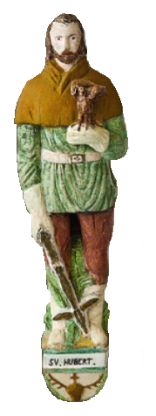

Vás srdečne pozývajú na

**SVÄTOHUBERTOVSKÚ OMŠU,**

ktorá sa uskutoční

**12. novembra 2017 o 18,30 hod.**

vo Františkánskom kostole Zvestovania Pána

v Bratislave

[](http://www.google.sk/url?sa=i&rct=j&q=&esrc=s&source=images&cd=&cad=rja&uact=8&ved=0ahUKEwjB5tfErNLPAhVHXBQKHfwEAkoQjRwIBw&url=http://www.ebay.com/itm/Mule-Deer-Buck-and-does-Scene-truck-window-tailgate-decal-bow-archery-hunt-/220672395912&bvm=bv.135258522,d.d24&psig=AFQjCNEWgGdxLoTKnZ6I2lNlS3Dyg6krLw&ust=1476261282697783)[](https://www.google.sk/url?sa=i&rct=j&q=&esrc=s&source=images&cd=&cad=rja&uact=8&ved=0ahUKEwjbw9XVq9LPAhWFUhQKHSvcDGEQjRwIBw&url=https://www.aliexpress.com/promotion/home-office-tools_duck-hunting-decals-promotion.html&bvm=bv.135258522,d.d24&psig=AFQjCNHg5bBJHPf81ph6PdcGlZcOQ3KxLA&ust=1476261192781626)



[](https://www.google.sk/url?sa=i&rct=j&q=&esrc=s&source=images&cd=&cad=rja&uact=8&ved=0ahUKEwjfvJ258s_PAhWD1xQKHceOAXQQjRwIBw&url=https://www.pinterest.com/pin/467389267551759227/&bvm=bv.135258522,d.d24&psig=AFQjCNFFDg0C-a9HULjPE84A21WkFuzbpw&ust=1476176987241153)